**Task 1: Business Information Systems and Processes**

Supply Chain Management (SCM)

In this ever-growing, modern society, humans are dependent on the concept of the supply chain to gain their produced goods and services. For example, the smartphone that we all own is made possible because the company that produced the smartphone has contracted a supplier to provide raw materials to the smartphone company to manufacture. This process is known as the supply chain. To put it simply, the supply chain is a network of relationships between the business itself and the supplier that supplies the raw materials to the business to manufacture and produce goods or services. To utilize the supply chain of a business most efficiently, businesses can increase their profits, productivity, reduce supply issues and provide better-optimized pricing for their products. This is known as Supply Chain Management. Many major businesses adopt this business practice to increase their profitability of the products and manage their supply chain most efficiently. Today, we will be using Apple Inc and its supply chain management as a case study to explore the effectiveness of Apple’s supply chain management practice to show that with the right business supply chain strategies can become very successful for future businesses. To understand why Apple has very successful supply chain management, it begins with the handling of their inventory.

Apple’s supply chain model is based on the handling of its inventory management. Apple likes to keep their inventory as low as possible and have a high inventory turnover to maximize their profits on the stock. Apple’s inventory turnover in 2021, had a ratio of 42.16. This means that Apple turns its inventory every 9 days on average (CSImarket, 2021). Turning the inventory every 9 days means that Apple on average keeps their stock for 9 days after manufacturing the product before selling it to the consumers. Having minimal stock in the inventory is important to Apple’s supply chain model as Apple has many competitors. If one of Apple’s competitors announces a new flagship product or a new innovative feature of their product design, this could bring down the value of the stock in the inventory as there could be less demand for the product (Clara, 2021). Therefore, having a high rate of inventory turnover means that Apple can sell their products at a relatively fast rate and keep their inventory stocks low to maximize profitability on each product and minimize the loss on the value of the stock from competitors. Apple’s example of good inventory management is crucial to the supply chain as inventory management facilitates the balance of supply and demand. This can be measured by using the inventory turnover ratio to efficiently calculate the rate of production for the product (Ben, 2020). This means that Apple can estimate the number of raw materials to purchase for the rate of production. By purchasing too many raw materials could increase inventory and decrease the inventory turnover ratio which can be financially costly to the company. By having a good balance of supply and demand, Apple can sell its products relatively quickly and generate revenue for the company without inventory waste. With excelling inventory management, Apple can maximize its profits on each product manufactured and this proposes the idea of how Apple is able to obtain its raw materials to be manufactured.

Apple is extremely strategic with its key suppliers for the manufacturing of the components in their products. Apple specifically has numerous exclusive long-term agreements with its key suppliers and prepays for raw materials from the supplier to negotiate better pricing terms and guarantee high levels of production of raw materials (Australian Institution of Company Directors, 2015). In addition, Apple uses multiple suppliers for the same component as these forces competitive pricing between the suppliers for the component (Julie, 2015). This also allows mitigating supply chain disruptions and delays by favoring one supplier over another if the supplier has issues with the production of the component. If demand should increase from consumers, Apple is able to quickly speed up production by allowing the suppliers to produce more of the same component within a short timeframe giving Apple the raw materials to manufacture their products. Because Apple has exclusive long-term agreements with its suppliers, this prevents competitors from utilizing the same production capacity through exclusive relationships with suppliers (Adam, 2018). Meanwhile, Apple also has fewer suppliers than other big tech companies, which means they can manage their suppliers better and faster (Ben, 2020). Therefore, Apple is strategically ahead of its competitors when it comes to production capacity as its competitors are forced to look for alternative raw materials suppliers.

In conclusion, Apple’s supply chain management is regarded as top-notch by many experts and it is clearly demonstrated by the little details that Apple pays attention to such as competitive pricing and inventory management. This all contributes the supply chain management as Apple successfully manages the supply chain between its suppliers and the manufacturing of the products to efficiently produce a product that is sold on the respective market relatively quickly generating faster rates of sale.

References:

CSI market. (2021). *Apple Inc Inventory Turnover Ratio (COS)*. Retrieved from [Apple Inc (AAPL) Inventory Turnover Ratio, from third quarter 2021 to third quarter 2020, current and historic results, rankings and more, Quarterly Fundamentals - CSIMarket](https://csimarket.com/stocks/singleEfficiencyit.php?code=AAPL)

Australian Institution of Company Directors. (2015). *A case study of Apple's supply chain*. Retrieved from [A case study of Apple's supply chain (companydirectors.com.au)](https://aicd.companydirectors.com.au/advocacy/governance-leadership-centre/governance-driving-performance/a-case-study-of-apples-supply-chain)

Clara, Lu. (2020). *Apple Supply Chain - The Best Supply Chain in the World.* Retrieved from [Apple Supply Chain - The Best Supply Chain in the World (tradegecko.com)](https://www.tradegecko.com/blog/supply-chain-management/apple-the-best-supply-chain-in-the-world)

Julie, Young. (2021). 9 Major Companies Tied to the Apple Supply Chain*.* Retrieved from [Apple's Supply Chain: The 9 Major Companies (investopedia.com)](https://www.investopedia.com/articles/investing/090315/10-major-companies-tied-apple-supply-chain.asp)

Ben, Benjabutr. (2020). Is Apple’s Supply Chain Really the No. 1? A Case Study*.* Retrieved from [Is Apple Supply Chain Really the No. 1? (supplychainopz.com)](https://www.supplychainopz.com/2013/01/is-apple-supply-chain-really-no-1-case.html)

Adam, Shrum. (2018).A Look at Apple’s Supply Chain Management*.* Retrieved from [A Look at Apple’s Supply Chain Management | Dynamic Inventory](https://www.dynamicinventory.net/apple-best-supply-chain-management-company/)

**Task 2: Business Process Improvement & Lean Operations**

Topic: Vehicle Insurance Business Practices

The business process of claiming car insurance after an accident can be quite tedious and frustrating as you have to sit through hour-long phone calls and are unable to do anything as your car could be inoperable.  Current car insurance business processes are based on the trust relationship between the insurer and the policyholder. There will be many assumptions towards this business process scenario as car insurance is a very wide topic that has many scenarios and each scenario has a different business process. In our analysis, we will be only focusing on one particular but common scenario - The assumption is that the policyholder has appeared to collide with an animal on the road. The vehicle has taken a substantial amount of damage from the impact and needs to be repaired but is still drivable. The policyholder has comprehensive insurance and covers the collision with the animal. Therefore, the policyholder decides to file for an insurance claim. The policyholder chooses a local mechanic that does not appear on the insurance’s companies list.

The current process of claiming car insurance when an accident occurs begins with a phone call to the insurance company to lodge an insurance claim after the accident has already occurred (Allizanz, 2021). During the initial phases of the phone call, the insurance spokesperson will request the policyholder’s personal details and policy number to confirm the existence of the insurance. The insurance spokesperson will ask for an accurate description of what had happened and the events leading up to the accident. Instructions will be provided over the phone to the policyholder to capture the accident or damage with a camera and/or provide dashcam footage if available. The policyholder will upload the evidence captured to the insurance’s website after entering the policy number to lodge the claim. The insurance company will review the evidence provided alongside the statement that the policyholder gave during the phone call. The insurance company will then decide whether to go ahead with the claim or to cancel the claim due to insufficient evidence or inconsistency with the statement and the policyholder will be notified by phone call. Should the claim procedure, the insurance company will ask the policyholder to select a mechanic of their choice and the policyholder will bring the vehicle to the mechanic for an inspection and quote. The mechanic will then provide the quote to the policyholder and the policyholder will provide the quote to the insurance company to review and pay. The insurance company accepts this quote and pays the policyholder the invoice amount in a cheque. The policyholder will then pay the mechanic for the repairs and once repairs are completed, the policyholder will collect the vehicle and the case is closed (Autoaccident.com, 2020).

This business process is also further portrayed on a process flowchart diagram to document the processes of filing an insurance claim after colliding with an animal on the page below.

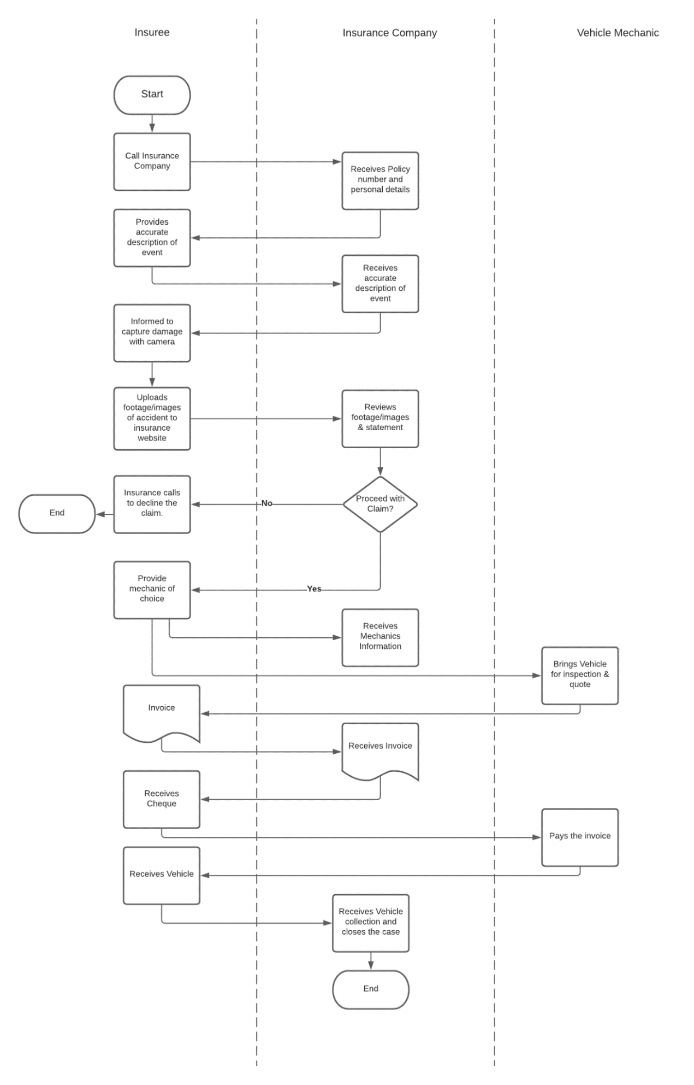

**Analysis**

The current business process appears to be quite tedious with evidence of inefficient business processes. On average, an insurance claim on a vehicle would take up to ten business days then taking the vehicle for repair would take an average of five working days for the assumed scenario established at the beginning of this report (Bundooramotorpanels, 2016). Therefore, it would take up to fifteen working days to lodge the claim and fully repair the vehicle. Fifteen working days to complete the claim and repair the vehicle appears to be substantially a long process as this limits the transportation factor of the policyholder as they should not operate the vehicle. The time it takes to complete this process is severely impacted by some of the processes where there are inefficiencies. Such inefficiencies in this process are highlighted by unnecessary back and forth communication between the policyholder, insurance company, and the mechanic near the end of the process. Otherwise, the process itself is relatively straightforward and it is a standard procedure for claiming insurance. The hindrance from the back-and-forth communication from the three entities will add an extra three business days to the process as there will be an assumption where the policyholder is unable to take the vehicle in until the weekend because of personal factors. Considering that it takes up to fifteen days only for the process to be completed, factoring in the personal factors will add to a total of eighteen days for the entire process. However, it is not always such easy to get insurance in a month, because there is no deadline for insurance sometimes the damage settlements spend years to decided, if people does not immediately contact with their insurance company (Gary, 2021). Therefore, this process is unconventional for an average policyholder to file an insurance claim.

**Revised Business Process Model**

Because of all the tedious processes in the business model, we can reduce the duration of completion of the business process. In this revised business process model, we will use the lean management approach. Lean management is an approach to managing an organization that supports the concept of continuous improvement and seeks to achieve incremental changes in the process in order to improve efficiency and quality (Emily, 2021). By adopting this approach, the elimination of unnecessary business processes will satisfy the lean-approach.

Firstly, the elimination of the back-and-forth communication between the policyholder, insurance company, and the mechanic. Because of the constant back and forth communication regarding the invoice, this creates inefficiency within the process as this could be resolved by direct communication between the mechanic and the insurance company. Although the mechanic is not under the insurance company’s mechanics list, the insurance company can communicate directly with the mechanic by cooperating with some designated mechanic or repair company. In this way the mechanic can directly provide the invoice to the insurance company without going through the policyholder. This would reduce a lot of processing time between the two companies. Thus, satisfying the elimination of waste in the lean principles (Emily, 2021).

Implementation of the lean operation in this business process model provides a minimalistic approach. We can improve the communication between the policyholder and the insurance company to effectively change the method of filing an insurance claim. In minor accidents like the given scenario, it is sometimes not necessary to speak over the phone to the insurance company unless in exceptional circumstances. It is better to adopt a mobile application that allows the policyholder to file an insurance claim over the app and upload the necessary photos and videos for the insurance company to review. Since the app will have instructions on how to file an insurance claim, it should be a relatively easy and simple process that satisfies the lean operation and its minimalistic approach.

With the proposed changes to the business model, the revised process of claiming insurance would begin by using your mobile device and opening the insurance application. On the application, there will be steps on how to file an insurance claim, the user will enter their policy number and personal details, followed by a description of what happened in the accident, and be asked to provide photos or videos in relation to the accident. Once it is submitted, the insurance company will review the insurance application and decide to either accept or decline. In the event where the policyholder is declined, they will be notified by email link to their policy number and a text will be sent. Should the application procedure, the insurance company request the policyholder to provide the mechanic details over the mobile application then the policyholder can bring their vehicle to the mechanic. The insurance will get in touch with the mechanic by phone letting them know that they will be paying for the invoice. The mechanic will inspect and provide an invoice to the insurance company and the insurance company will pay for the invoice. Then the policyholder will collect their vehicle.

This revised business process is also further portrayed on a process flowchart diagram to document the processes of filing an insurance claim after colliding with an animal on the page below.

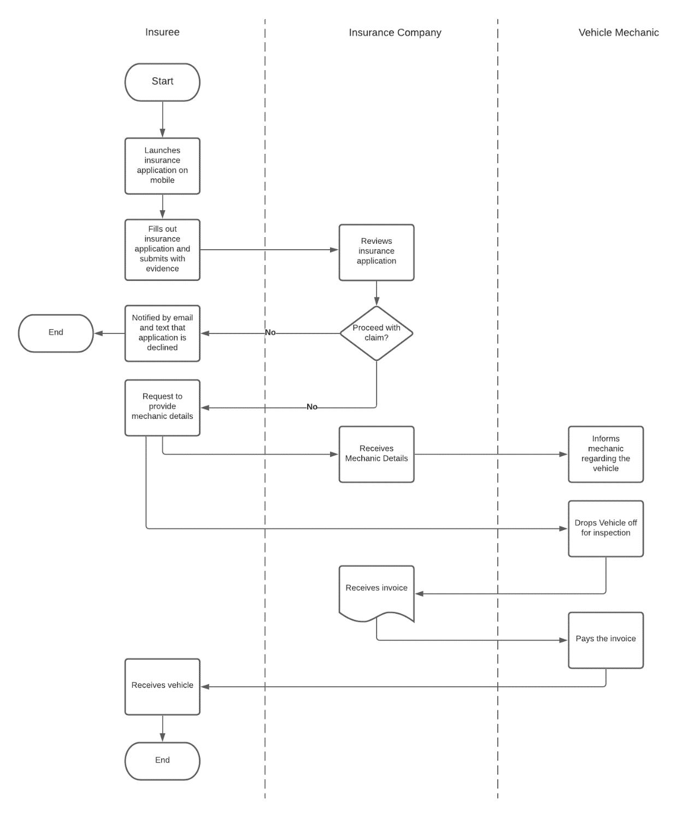

**Business Process Performance Analysis**

In the two provided process flowcharts for the current and revised business processes model, we can see that there are clearly some significant differences between the two. The current business process model has a lot more entities on the flowchart, therefore, complicating the process. As in the revised business process model, the back and forth communication between the policyholder, insurance company, and the mechanic has been removed and it evidently shows the uncomplicated nature of this business model. Thus, this business model is far more efficient than the current business process model. The revised business process model uses an integrated mobile application to file an insurance claim which in this given scenario would be a lot more applicable since the accident is not classified as severe. The revised business process satisfies the Lean operations by cutting down on wasted energy, resources, and time (Lorenzo, 2018).

**Role of Information Technology (IT) / Business Information Systems (BIS) in revised business process**

The role of IT and BIS is clearly presented in the revised business process. By switching from a phone call format to lodge an insurance application to filling the application on a mobile device shows the advancement of technology where human labour is no longer necessary in such operations and can be replaced by software. In addition, the role of BIS enhances the business process by eliminating unnecessary processes that hinder the business process and causing unnecessary delays to the insurance application. By adopting lean management and lean operation, the inefficiencies of the business process were eliminated and created a simple but yet effective business process. The roles of both IT and BIS interconnect in this revised business process to create a more viable, efficient, and minimalistic business process (Jonas et al,2014). Therefore, this revised business process approach in comparison to the current approach adopts and employs more elements of IT and BIS modelling.

References:

Allizanz. (2021). *Steps for making a car insurance claim*. Retrieved from <https://www.allianz.com.au/news/steps-for-making-a-claim.html>

Autoaccident.com. (2020), *Laws on Automotive Repair in California*. Retrieved from <https://www.autoaccident.com/laws-on-automotive-repair-in-california.html>

Bundooramotorpanels. (2016)*. How long will it take to fix my car?*. Retrieved from [How Long Does it Take to Fix a Car? - Bundoora Motor Panels](http://www.bundooramotorpanels.com.au/blog/how-long-will-it-take-to-fix-my-car#:~:text=On%20average%2C%20most%20smash%20repairs,be%20completed%20within%20a%20day)

Emily, McLaughlin. (2019). *Lean management*. Retrieved from [What is Lean Management (techtarget.com)](https://searchcio.techtarget.com/definition/lean-management)

Gary, Hunter. (2021). *Car Insurance Claims* Retrieved from [Complete Guide to Car Insurance Claims October 2021 | Finder](https://www.finder.com.au/car-insurance-claims)

Lorenzo, Del, Marmol. (2018). *What is Lean Management in Insurance?*. Retrieved from [Lean Insurance Management Programs Implemenation - Len Siz Sigma Belgium (leansixsigmabelgium.com)](https://leansixsigmabelgium.com/blog/lean-insurance/)

Jonas, Montilva., & Judith, Barrios,. & Isabel, Besembel,. & William, Montilva. (2014). *A Business Process Model for IT Management Based on Enterprise Architecture.* Retrieved from [A Business Process Model for IT Management Based on Enterprise Architecture (scielo.edu.uy)](http://www.scielo.edu.uy/scielo.php?script=sci_arttext&pid=S0717-50002014000200004)

**Task 3: Emerging trends in Business Information Systems**

There are a lot of elements involved while talking about the nature of business. However, if we think from the bottom up to understand the whole business, the nature of business is trading with products or services (Incorporated zone, 2021). While the business is getting bigger and the appearance of challenges like globalization or Covid-19, there is more information and data that needs to be integrated and analyzed. Without the help of BIS practitioners, the whole business will go inefficient, which is hard to keep producing high-quality goods and services (Stair & George, 1992), then bring a bad indirect effect on business revenue. On the other hand, The BIS brings the advantage of competing in the global market (Stair & George, 1992), the main performance is improving value while reducing the expenditure and improving the product and service (Collins, 2001). Meanwhile, to gain an advantage over the other competitors, the company has to continually analyze their resources and make a usage decision with the data or record they have. On the technical aspect, E-commerce is occupying more part of the company’s processes and also streamlining work by making the process automated (Stair & George, 1992). In this competitive environment, BIS is indispensable and plays a key role. Being a BIS practitioner, Not only requires abundant knowledge about data systems but also extensive business knowledge, this is because, after setting foot in both aspects, the BIS practitioner can quickly notice the performance of the business process (USYD, 2021). There are more and more companies that need this type of talent that could examine the enterprise information and data, also using BIS strategically on business process improvement (USYD, 2021). Moreover, As BIS plays a more important role in analyzing the performance of the business, BIS practitioners are more inclined to be business analysts (indeed.com, 2021), this means that BIS practitioners also need to possess strong and rich qualities. The rich qualities are mainly reflected in management skills, teamwork skills, critical thinking, and leadership, all of these could make a good business analysis enable the team to deliver high-quality results in a high-pressure workplace (Australian Bureau of Statistics, 2021). Hence, the great BIS practitioners will build a toolbox of skills and use it to solve similar problems in a different way to improve the effectiveness and increase marketability (Laura Brandenburg, 2021)

Reference:

Incorporated, zone. (2021) *Nature of Business*: Retrieved from [Nature of Business (What It Is And What You Must Know) (incorporated.zone)](https://incorporated.zone/nature-of-business/)

Ralph, M., Stair, & George, W., Reynolds. (1992). *Principles of Information Systems*, Chapter 1&2, 9th Edition

Jim, Collins. (2001). *Good to Great*, HarperCollins Edition: Page. 300

The, University, of, Sydney. (2021). *Business Information Systems*. Retrieved from [Business Information Systems - The University of Sydney](https://www.sydney.edu.au/courses/subject-areas/major/business-information-systems0.html)

indeed.com. (2021). *Business Information System Jobs*. Retrieved from  [Business Information System Jobs (with Salaries) 2021 | Indeed.com Australia](https://au.indeed.com/jobs?q=Business%20Information%20system&l&vjk=e43e15247ff1786a&advn=7841578980725102)